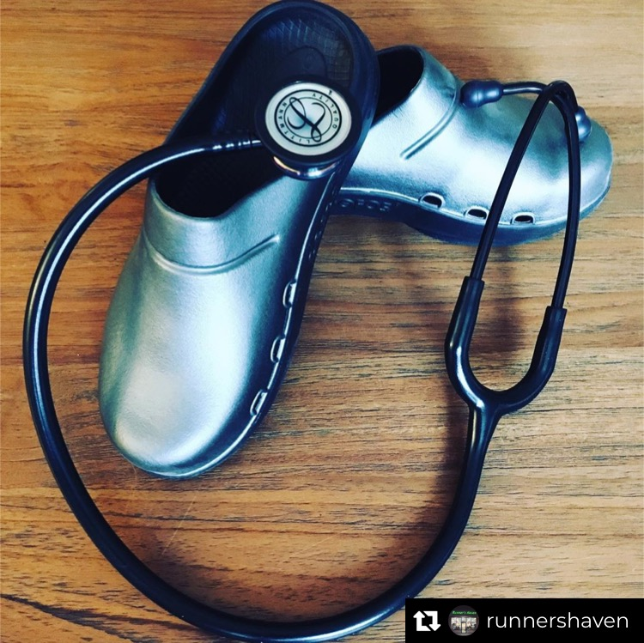

The Healthcare Community Needs Your Help!

We have had multiple generous patrons purchase Oofos clogs to be donated to healthcare workers at Morristown Memorial Hospital. They are desperately needed to be shared amongst workers going into COVID-19 isolation rooms, in order to be disinfected/washed/bleached after each wear. Now, we are INSPIRED! For every 5 pairs purchased for donation by our Runner’s Haven Community (cumulatively, not individually), we will donate an additional pair. We may not have masks, but we can make sure our healthcare workers have the right shoes to stay safe! We will arrange to have the clogs delivered to Morristown Memorial Hospital via our hospital contact and distributed to Saint Clare’s and Dover based on need and donations. Call us at 973-361-9100. Be sure to leave your name and number for us to finalize your purchase.

Hard Times Need Good Soles, so Help Us Keep Healthcare Workers on Their Feet

🏥

